**LOGISTIC REGRESSION**

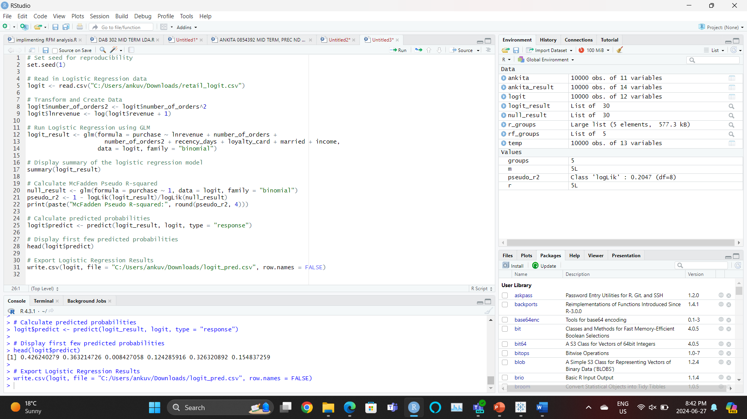

1. Read in the Logistic Regression data file. To do this, you need to select the data file (*retail_logit*.csv) on your computer to run the code.
2. Now, we have the opportunity to create new variables or transform current variables to see if we can establish a stronger relationship between the transaction and customer characteristic variables and the decision to purchase. We decide to create one variable, the square of frequency (*number_of_orders*^2), as based on prior experience we believe that customers who purchase at a moderate frequency are, all else being equal, more likely to continue purchasing for longer into the future.
3. We note two things here.
   1. First, we included seven independent variables in the model. These included *lnrevenue* (natural log of revenue), *number_of_orders* (frequency), *number_of_orders2* (frequency^2), *recency_days*, *loyalty_card*, *married*, and *income*.
   2. Second, we run the summary command on the result of the model to see the model fit and coefficients.

Call:

glm(formula = purchase ~ lnrevenue + number_of_orders + number_of_orders2 +

recency_days + loyalty_card + married + income, family = "binomial",

data = logit)

Coefficients:

Estimate Std. Error z value Pr(>|z|)

(Intercept) -5.090e+00 2.323e-01 -21.914 < 2e-16 ***

lnrevenue 1.938e-01 4.181e-02 4.636 3.56e-06 ***

number_of_orders 3.842e-02 5.512e-03 6.969 3.19e-12 ***

number_of_orders2 -1.350e-04 4.516e-05 -2.990 0.00279 **

recency_days -1.729e-03 1.615e-04 -10.704 < 2e-16 ***

loyalty_card 8.955e-01 6.271e-02 14.281 < 2e-16 ***

married 7.840e-01 6.137e-02 12.775 < 2e-16 ***

income 1.398e-02 7.664e-04 18.241 < 2e-16 ***

---

Signif. codes: 0 ‘***’ 0.001 ‘**’ 0.01 ‘*’ 0.05 ‘.’ 0.1 ‘ ’ 1

(Dispersion parameter for binomial family taken to be 1)

Null deviance: 9363.9 on 9999 degrees of freedom

Residual deviance: 7446.9 on 9992 degrees of freedom

AIC: 7462.9

Number of Fisher Scoring iterations: 5

> # Calculate McFadden Pseudo R-squared

> null_result <- glm(formula = purchase ~ 1, data = logit, family = "binomial")

> pseudo_r2 <- 1 - logLik(logit_result)/logLik(null_result)

> print(paste("McFadden Pseudo R-squared:", round(pseudo_r2, 4)))

[1] "McFadden Pseudo R-squared: 0.2047"

>

> # Calculate predicted probabilities

> logit$predict <- predict(logit_result, logit, type = "response")

>

> # Display first few predicted probabilities

> head(logit$predict)

[1] 0.426240279 0.363214726 0.008427058 0.124285916 0.326320892 0.154837259

LINK-

<https://public.tableau.com/views/predictedvsactualpurchaseforeachcustomerLRA/Sheet1?:language=en-US&publish=yes&:sid=&:display_count=n&:origin=viz_share_link>

EMBADDED CODE-

<div class='tableauPlaceholder' id='viz1719535447035' style='position: relative'><noscript><a href='#'><img alt='Predicted vs. Actual Purchase for Each CustomerAnkita VashishtW08543392 ' src='https:&#47;&#47;public.tableau.com&#47;static&#47;images&#47;pr&#47;predictedvsactualpurchaseforeachcustomerLRA&#47;Sheet1&#47;1_rss.png' style='border: none' /></a></noscript><object class='tableauViz' style='display:none;'><param name='host_url' value='https%3A%2F%2Fpublic.tableau.com%2F' /> <param name='embed_code_version' value='3' /> <param name='site_root' value='' /><param name='name' value='predictedvsactualpurchaseforeachcustomerLRA&#47;Sheet1' /><param name='tabs' value='no' /><param name='toolbar' value='yes' /><param name='static_image' value='https:&#47;&#47;public.tableau.com&#47;static&#47;images&#47;pr&#47;predictedvsactualpurchaseforeachcustomerLRA&#47;Sheet1&#47;1.png' /> <param name='animate_transition' value='yes' /><param name='display_static_image' value='yes' /><param name='display_spinner' value='yes' /><param name='display_overlay' value='yes' /><param name='display_count' value='yes' /><param name='language' value='en-US' /><param name='filter' value='publish=yes' /></object></div> <script type='text/javascript'> var divElement = document.getElementById('viz1719535447035'); var vizElement = divElement.getElementsByTagName('object')[0]; vizElement.style.width='100%';vizElement.style.height=(divElement.offsetWidth*0.75)+'px'; var scriptElement = document.createElement('script'); scriptElement.src = 'https://public.tableau.com/javascripts/api/viz_v1.js'; vizElement.parentNode.insertBefore(scriptElement, vizElement); </script>

LINK-

<https://public.tableau.com/views/predictedvsactualpurchaseforeachcustomer__LRA/Sheet1?:language=en-US&publish=yes&:sid=&:display_count=n&:origin=viz_share_link>

CODE EMBADDED-

<div class='tableauPlaceholder' id='viz1719535710071' style='position: relative'><noscript><a href='#'><img alt='Predicted vs. Actual Purchase for Each CustomerAnkita VashishtW08543392 ' src='https:&#47;&#47;public.tableau.com&#47;static&#47;images&#47;pr&#47;predictedvsactualpurchaseforeachcustomer__LRA&#47;Sheet1&#47;1_rss.png' style='border: none' /></a></noscript><object class='tableauViz' style='display:none;'><param name='host_url' value='https%3A%2F%2Fpublic.tableau.com%2F' /> <param name='embed_code_version' value='3' /> <param name='site_root' value='' /><param name='name' value='predictedvsactualpurchaseforeachcustomer__LRA&#47;Sheet1' /><param name='tabs' value='no' /><param name='toolbar' value='yes' /><param name='static_image' value='https:&#47;&#47;public.tableau.com&#47;static&#47;images&#47;pr&#47;predictedvsactualpurchaseforeachcustomer__LRA&#47;Sheet1&#47;1.png' /> <param name='animate_transition' value='yes' /><param name='display_static_image' value='yes' /><param name='display_spinner' value='yes' /><param name='display_overlay' value='yes' /><param name='display_count' value='yes' /><param name='language' value='en-US' /><param name='filter' value='publish=yes' /></object></div> <script type='text/javascript'> var divElement = document.getElementById('viz1719535710071'); var vizElement = divElement.getElementsByTagName('object')[0]; vizElement.style.width='100%';vizElement.style.height=(divElement.offsetWidth*0.75)+'px'; var scriptElement = document.createElement('script'); scriptElement.src = 'https://public.tableau.com/javascripts/api/viz_v1.js'; vizElement.parentNode.insertBefore(scriptElement, vizElement); </script>

Link-

<https://public.tableau.com/views/HitRateLRA/Sheet2?:language=en-US&publish=yes&:sid=&:display_count=n&:origin=viz_share_link>

code embedded-

<div class='tableauPlaceholder' id='viz1719538550572' style='position: relative'><noscript><a href='#'><img alt=' Hit Rate&#47;Confusion Matrix TableAnkita VashishtW0854392 ' src='https:&#47;&#47;public.tableau.com&#47;static&#47;images&#47;Hi&#47;HitRateLRA&#47;Sheet2&#47;1_rss.png' style='border: none' /></a></noscript><object class='tableauViz' style='display:none;'><param name='host_url' value='https%3A%2F%2Fpublic.tableau.com%2F' /> <param name='embed_code_version' value='3' /> <param name='site_root' value='' /><param name='name' value='HitRateLRA&#47;Sheet2' /><param name='tabs' value='no' /><param name='toolbar' value='yes' /><param name='static_image' value='https:&#47;&#47;public.tableau.com&#47;static&#47;images&#47;Hi&#47;HitRateLRA&#47;Sheet2&#47;1.png' /> <param name='animate_transition' value='yes' /><param name='display_static_image' value='yes' /><param name='display_spinner' value='yes' /><param name='display_overlay' value='yes' /><param name='display_count' value='yes' /><param name='language' value='en-US' /><param name='filter' value='publish=yes' /></object></div> <script type='text/javascript'> var divElement = document.getElementById('viz1719538550572'); var vizElement = divElement.getElementsByTagName('object')[0]; vizElement.style.width='100%';vizElement.style.height=(divElement.offsetWidth*0.75)+'px'; var scriptElement = document.createElement('script'); scriptElement.src = 'https://public.tableau.com/javascripts/api/viz_v1.js'; vizElement.parentNode.insertBefore(scriptElement, vizElement); </script>